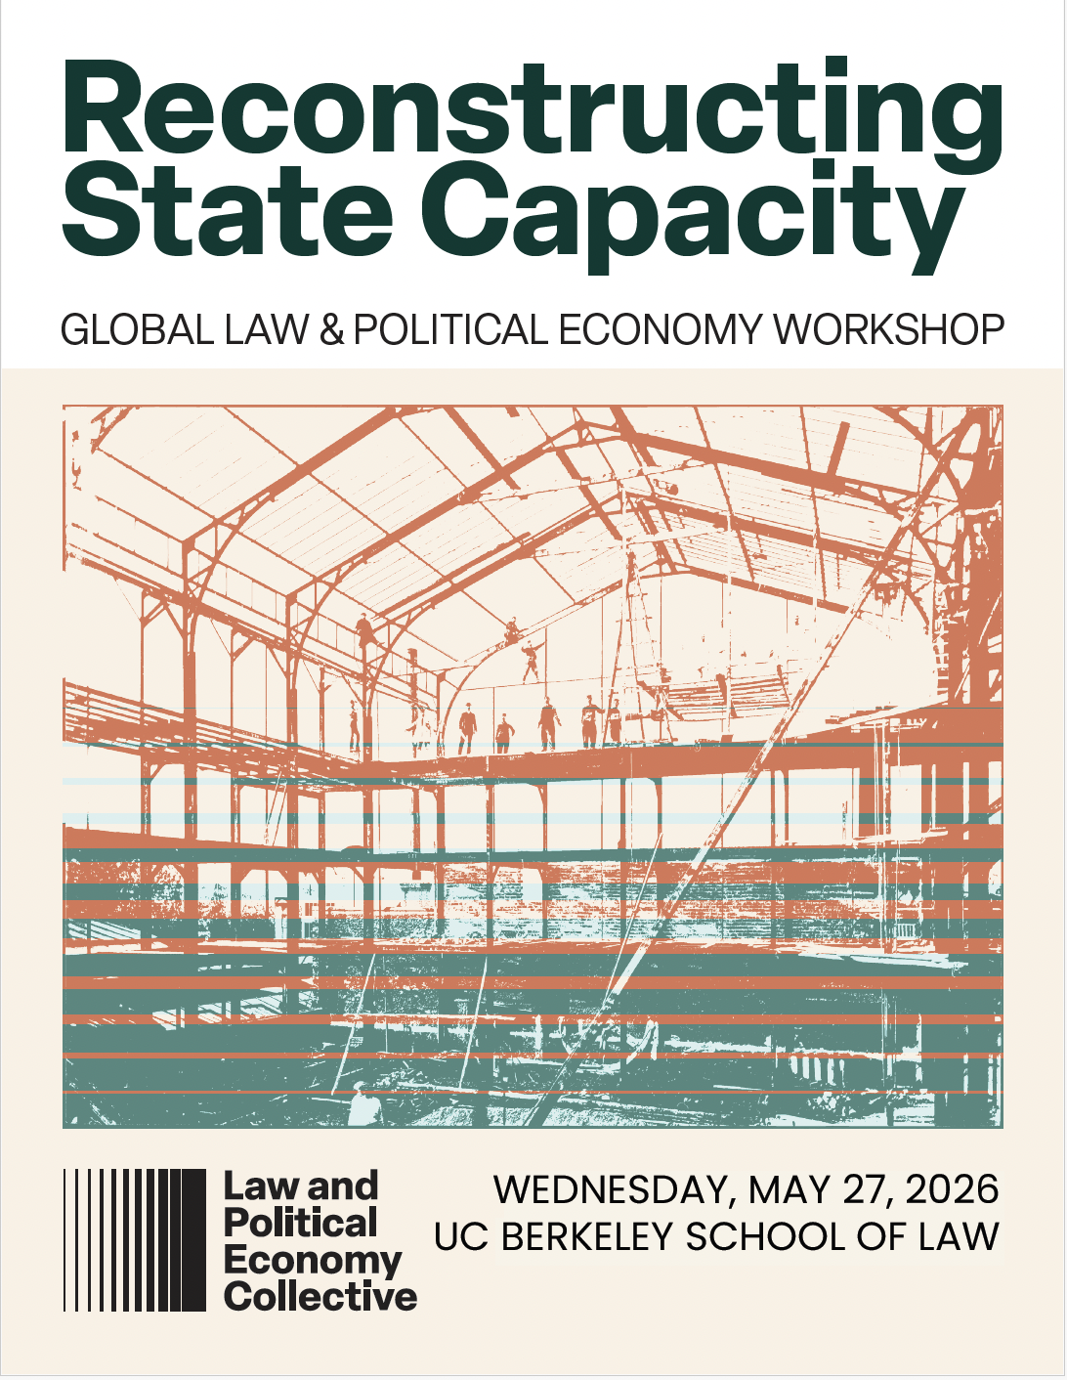
2026 Global Law & Political Economy Workshop
Reconstructing State Capacity
May 27, 2026
Berkeley, California
*All pre-circulated papers available in the shared Google Drive folder
09:00 – 09:30 Welcome & Introduction to the Workshop
09:30 – 11:00 Plenary 1. The Fragmented State: Retrenchment, Redeployment, and the Limits of Public Authority Goldberg Room
Chair: Steven Vogel, UC Berkeley
John W. Cioffi, University of California, Riverside
The Crisis of Countervailing Power: State Capture and the Paradox of State Capacity
Matthew Dimick, University at Buffalo School of Law
After Administration
Yael Cohen-Rimer, Hebrew University Law Faculty
Constitutional Abandonment: Reimagining State Capacity and Social Rights in the Wake of Emergency
Daniela Campos Ugaz, Emory University
Constrained Autonomy: State Capacity, Skills Sourcing, and the Knowledge Economy in Costa Rica
11:00 – 11:15 C O F F E E B R E A K
11:15 – 12:45 Breakout Groups – A1, B1, C1
A1 State Capacity and the Distribution of Violence Room 107
Discussant: Yael Cohen-Rimer, Hebrew University
Isaac Dalke, Northeastern University & Harvard University
Making the Delegated Penal State: Alternatives to Policing in California, 1990-2005
Marissa Jackson Sow, University of Richmond School of Law
Getting Away with Social Murder
Ran Yan, UC Berkeley
The Price of Crime: Livestock Theft and Legal Pluralism in Eighteenth-Century Qing Khalkha Mongolia
Trevor Gardner, WashU Law School
Fugitive Slave Rendition and the Preemption and Appropriation of State and Local Criminal Administration
B1 State Capacity and Transnational Governance Room 111
Discussant: Susan Silbey, MIT
Giovanna Teixeira, FGV São Paulo Law School
The Paradox of Regulatory Success in the Global South: State Capacity at Brazil’s ANVISA
Chung-Ying Lee, Minnan Normal University
Governing the Ungovernable: How Law Mediates Regulatory Breakdown in Cross-Strait Food Safety Cooperation
Karim Medjad, Conservatoire National des Arts et Métiers Paris
The Commodification of Sovereignty: Special Zones and Territorial Authority
Annelisa Kingsbury Lee, Stanford Law School
Salt and Oysters: Legislative Sovereignty, Property, and the Public Trust in Nineteenth-Century Texas and New Jersey.
C1 State Capacity, Expertise, and Organizing Logics of Governance Room 113
Discussant: John W. Cioffi, University of California, Riverside
Stephen Cody, Suffolk Law School
State Capacity and Epistemic Sufficiency in the Deep Sea
J. Benton Heath, Temple University School of Law
The Chokepoint State
Michaeljit Sandhu, Harvard Law School
Unmasking Presidential Administration
Nazune Menka, Seattle University
LPE & Plenary Power
13:00 – 14:00 L U N C H B R E A K
14:00 – 15:30 Plenary 2. Building Capacity, Containing Contradiction: Legal Architectures of Governance Goldberg Room
Chair: Jedidiah Kroncke, The University of Hong Kong
Jason Jackson, MIT
Taxis vs Uber: Planning vs Markets, or Markets as Planning?
Shruti Rana, University of Missouri
Weaponizing State Inaction: Theorizing the Care Crisis in International Law from the Pandemic to the Present
Jodi Short, UC Law San Francisco
Organizational Dimensions of the Civil Service Purge
Francis Cao, Goethe University Frankfurt & Friedrich Alexander University at Nuremberg-Erlangen
Selective Coupling as State Capacity: How Law Constructs Governing Capacity Through the Management of Contradiction
15:30 – 15:45 C O F F E E B R E A K
15:45 – 17:15 Breakout Groups – A2, B2, C2
A2 State Capacity, Labour, and the Politics of Engagement Room 107
Discussant: Diana Reddy, UC Berkeley
César F. Rosado Marzán, University of Iowa College of Law
Expertise, Embeddedness, and Power: Rebuilding the Administrative State After Trump
Yiran Zhang, Cornell University Industrial and Labor Relations School
Profit Convergence and the Marketization of Public Care
Henrique Almeida de Castro, University of Konstanz
From Antagonizing to Participating In the State: Union Choice and Factional Conflict in Brazil, South Africa, and South Korea
B2 State Capacity, Technology, and Technocratic Power Room 111
Discussant: Jason Jackson, MIT
Hung-Wei Liao, NYCU School of Law Taiwan
The Convergence of AI and Bureaucracy in Public Governance: On the Emergence of “Double Formalism”
Julian Hsiang Luo, National Taiwan University College of Law
The “Silicon Shield” as State Capacity: Reconstructing Sovereignty and Regulatory Capture in Taiwan’s Semiconductor Governance
Emma Goh, UC Berkeley
A Region Reconstituted: Techno-Regionalism in the SIJORI Triangle
C2 Courts and the Legal Infrastructure of State Capacity Room 113
Discussant: Bronwen Morgan, UNSW Sydney
Yong-Cheng Lai, University of Minnesota
State Capacity and Constitutional Review of Taxation: A Taiwan Case Study
Inbal Maimon Blau, Ono Academic College
Managing Historical Accountability: Tort Litigation and the Limits of State Capacity in Israel
Mao-hong Lin, National Taipei University Graduate School of Criminology
The Engagement of Criminal Law in Taiwan’s Currency Transformation
Juan Carlos Ibarra, University of San Francisco School of Law
State Capacity, Citizenship, and Legal Vulnerability in Family Trust Law
17:15 – 17:30 Concluding Remarks Goldberg Room

The 2026 Global Law & Political Economy Workshop is supported by the LPE Collective and the UC Berkeley School of Law. Special thanks to Professor Jonathan Simon for his support for the workshop and its planning.

2026 Global Law & Political Economy Workshop: Attendees
- Inbal Maimon Blau, Ono Academic College
- Daniela Campos Ugaz, Emory University
- Henrique Almeida de Castro University of Konstanz
- John W. Cioffi University of California, Riverside
- Stephen Cody Suffolk Law School
- Yael Cohen-Rimer Hebrew University Law Faculty
- Isaac Dalke Northeastern University & Harvard University
- Matthew Dimick University at Buffalo School of Law
- Trevor Gardner WashU Law School
- Emma Goh UC Berkeley
- Maj Grasten Copenhagen Business School
- Matt Hamilton UC Berkeley
- J. Benton Heath Temple University School of Law
- Carol Heimer Northwestern University
- Juan Carlos Ibarra University of San Francisco School of Law
- Jason Jackson MIT
- Minju Kang Harvard Law School
- Annelisa Kingsbury Lee Stanford Law School
- Reshard Kolabhai Yale Law School
- Jedidiah Kroncke The University of Hong Kong
- Yong-Cheng Lai University of Minnesota
- Chung-Ying Lee Minnan Normal University
- Hung-Wei Liao NYCU School of Law, Taiwan
- Haozhou Lin UC Berkeley
- Mao-hong Lin National Taipei University Graduate School of Criminology
- Julian Hsiang Luo National Taiwan University College of Law
- César F. Rosado Marzán University of Iowa College of Law
- Karim Medjad Conservatoire National des Arts et Métiers Paris
- Nazune Menka Seattle University
- Bronwen Morgan UNSW Sydney
- Gunar Olsen UC Berkeley
- Lucas Osborne UC Berkeley
- Shruti Rana University of Missouri
- Diana Reddy UC Berkeley
- Nancy Reichman University of Denver
- Michaeljit Sandhu Harvard Law School
- Isabelle Schmitt Universität Kassel
- Sarang Shah UC Berkeley
- Jodi Short UC Law San Francisco
- Susan Silbey MIT
- Jonathan Simon UC Berkeley
- Marissa Jackson Sow University of Richmond School of Law
- Giovanna Teixeira FGV São Paulo Law School
- Jay Varellas UC Berkeley
- Steven Vogel UC Berkeley
- Ran Yan UC Berkeley
- Yiran Zhang Cornell University Industrial and Labor Relations School

Workshop Organizers
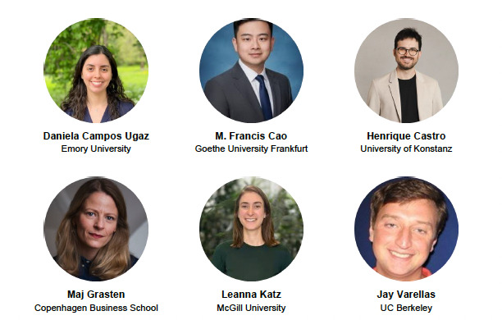

Law and Political Economy Initiatives
A selection of networks, projects, and programs in the LPE field
The Law and Political Economy Collective
The LPE Collective is an international, interdisciplinary community of scholars examining how law structures power, markets, and economic institutions. It hosts the annual Global Law and Political Economy Workshop, organizes panels and workshops at major events including SASE and EAEPE, and supports regional workshops, PhD schools, and emerging scholars through its Early Career Scholars Network. It supports the LSA Collaborative Research Network on Law and Political Economy (CRN 55), founded by LPE Collective members in 2017, and has seeded further initiatives including the LPE in Latin America network. Visit lpecollective.org.
The Association of Law & Political Economy (ALPE)
ALPE is a membership organization dedicated to scholarship that centers political economy in the study of law. Defining scholarship broadly to include writing, teaching, and advocacy, it attends to inequality, power, subordination, and intersectionality, and hosts an annual conference alongside other gatherings and programming. Visit lawandpoliticaleconomy.org.
Law and Political Economy in Europe
LPE in Europe is a movement of scholarship and legal praxis showing how law contributes to social, economic, and ecological crises — and how it could help address them. It brings together academics and civil society to re-imagine legal structures, advance strategic litigation on systemic enablers of economic power, and develop an open collaborative syllabus. It convenes an annual Summer Academy, with the fourth in Glasgow in 2026. Visit lpeineurope.org.
Law & Political Economy in Latin America
LPE in Latin America strengthens theoretical and methodological debates about Law and Political Economy within the Latin American context and expands the global reach of LPE research originating in the region. To learn more about events and opportunities, contact lpelatam@gmail.com.
Global Law & Social Reproduction Network (GLARE)
GLARE brings together scholars working at the intersection of law and social reproduction through monthly virtual seminars, reading discussions, and book talks. The series culminates in an in-person workshop in Copenhagen in October 2026, supported by an LSA Advance Grant. To join, email Maj Grasten (mg.bhl@cbs.dk) with your name, email, discipline, position/institutional affiliation (if any), and country of residence.
Journal of Law and Political Economy (JLPE)
A peer-reviewed, open-access journal promoting multi- and interdisciplinary analyses of the interactions among law, society, institutions, and politics, with a central focus on power in its many forms and its relationship to law. Visit escholarship.org/uc/lawandpoliticaleconomy.
Law and Political Economy eJournal (SSRN)
Published by the LPE Collective, this eJournal features interdisciplinary scholarship on law, politics, and economics as interrelated systems of contested power. Subscribe or access content free through the SSRN website.

